

Taming of the Stew - the competing cooks and their recipes.

Who would have wanted the job of picking one winner out of these? They were all so different.

The proud winner was Janet Tudor from The Pentre. Janet and her husband have a time-share in Italy, so she went all Italian on us tonight with an Agrodolce recipe, which is a sort of sweet and sour approach. This particular recipe is from food writer, artist and broadcaster, Elisabeth Luard, who is also Chair Emerita of the Oxford Food Symposium on Food and Cookery.

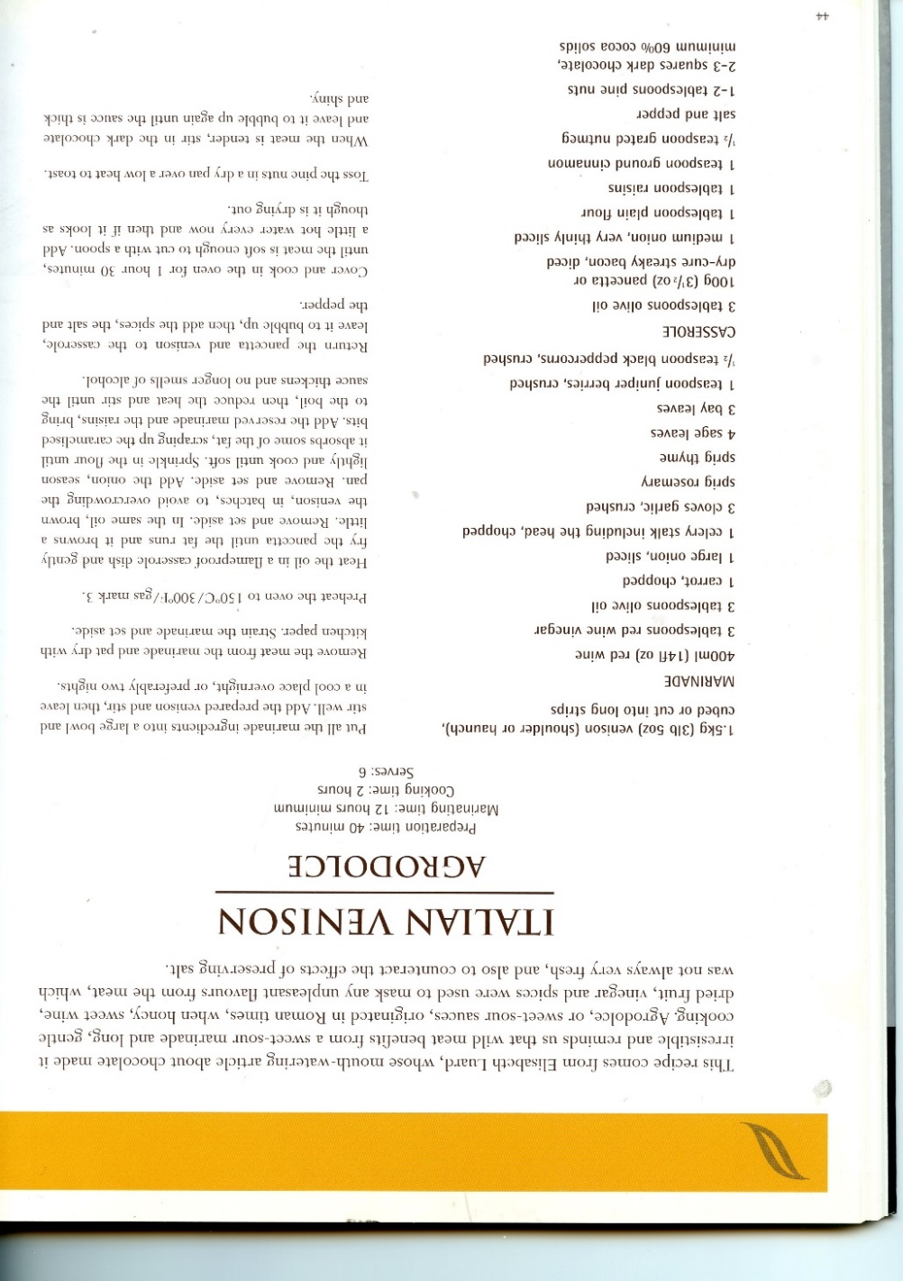

The Worthy Runners-up

Simon Jameson from New Invention. Simon made his recipes up on the (cloven?) hoof. Clearly, he is an instinctive cook, but what else would you expect from an artist? All he would say about the evening’s offering was, “The venison was braised and slow cooked with various locally sourced vegetables and there was a secret ingredient which I can’t divulge.” Later he opened up further by saying there were actually three secret ingredients which he wasn’t prepared to divulge. It rather sounds as though one of those secret ingredients was magic mushrooms making the casserole a completely new invention.

Alison Gunning-Stevenson from Bucknell. Clearly, Alison had been thinking about her recipe for a long time because as soon as the call went out to know what ingredients were to be used, she replied straight away. What dedication, and here’s how she describes her casserole: Description: Braised Venison with Pumpkin and Chestnuts. Method: Marinated for 24 hours prior to braising. Ingredients: Venison, streaky bacon, bay leaves, thyme and Juniper Berries, Cote du Rhone wine, red onion, garlic, carrots, beef stock, pumpkin, chestnuts. Alison is a keen balloonist, but it’s clear from this list that tonight she’s not had her head in the clouds.

James Middleton from Chapel Lawn. James is (in)famous for his winning squirrel pie some years ago. Let’s hope he realized that tonight was ‘Taming of the Stew’ and not ‘Tasting of the Shrew’. But, no, he wouldn’t have done that, would he? James’ recipe included pork sausage, streaky bacon, mushrooms, carrots, white onion, and red wine, all slowly simmered in the Aga.

Ryan Davies from Heyope. As chairman of Clun Town Council, Ryan asked if the announcement of the winner could be carefully minuted for lengthy debate and final approval at the next Council meeting. But we’re a stroppy lot in Chapel Lawn, so we over-ruled him. Ryan’s approach was to first soak the venison in milk for six hours and then cook it in port, red wine and chicken stock with the addition of celery, onions, carrots and red currant jelly, before keeping it in the Rayburn for a further six hours.

Karen Sharpe from Bucknell. Karen is another balloonist (you don’t see one for ages then they all come along at the same time), but on this occasion she came by car. Her approach was to marinade overnight in red wine and beef stock. The recipe included herbs (parsley, thyme, rosemary), carrots, mushrooms, bacon, celery, onions, tomato paste. That all sounds pretty good.

