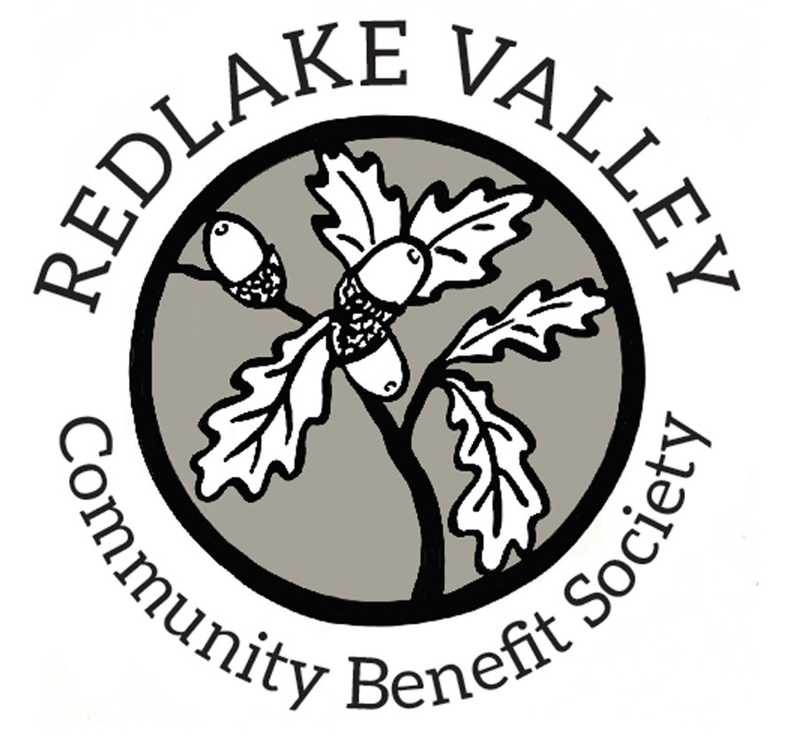
Minutes of Board Meeting
Held at Redlake Valley Village Hall
On Tuesday 28th September 2021 at 4pm

Present: Patrick Cosgrove (PC) Bob James (BJ) Simon Jameson (SJ) Mark Limbrick (ML) Anthony Morgan (AM)

1. Welcome: ML as chairman welcomed members

2. Apologies: Sara Randall

3. Declaration of interests: None

4. Minutes of last meeting (25th February and 30th April 2021):
The Board agreed the minutes.

Matters arising from the minutes:
25th February:
11. Society’s documents and data: Data had not yet been passed on to SR. Action AM, ML
15. Village notice board: Information about fundraising and upcoming events had not yet been posted. Action PC

5. Chairman’s report:
Ros Patching had resigned from the board. Members expressed their regret but were grateful for the contributions she had made and pleased that she remained an active shareholder. Covid-19 restrictions had made formal work parties difficult but there were still plenty of people keen to contribute to the Society’s activities.

6. Treasurer’s report:
The bank balance was £4981.08 with about £100 of issued cheques not cleared because the publisher of Broadsheep had not taken them to a bank. The draft annual accounts had been circulated to members by email and showed a satisfactory overall financial position. In advance of the AGM two board members will need to scrutinize and sign the income and expenditure ledger. Action AM and other members

7. RVCBS AGM 2021 – arrangements:
Because of the need to make the annual return to the Financial Conduct Authority before the end of October it was agreed to arrange the AGM for Wednesday 27th October at 7pm. This timescale will allow invitations to be sent to shareholders in accordance with the rules but because of continuing hesitancy about group meetings the AGM would be held by Zoom rather than in person. Action ML, AM

8. SWA project update:
As recorded in the minutes of April 2021, the board had received a proposal from Nick Marsh, on behalf of the Smallwoods Association, to take part in a woodland management scheme financed by Severn Trent Water Authority. Nick had subsequently left employment with Smallwoods and despite multiple attempts by AM to get further information from Smallwoods none had yet been received. The likelihood that the project still exists appears small but there seems little that can be done at the moment but to await events.

9. Woodland work parties 2021/22:
ML proposed dates of 31st October, 28th November, 23rd January 2022, 27th February, 27th March, and 24th April. Karen Limbrick had agreed to co-ordinate activities and to send advertisements to shareholders. Objectives included step construction and maintenance, limited bramble clearing, collect felled wood, support the edge of the path between the two quillets, smarten the notice board and plant some New Forest oak seedlings to provide an element of genetic diversity. Action ML,PC

10. Redlake 3 in 1 event update:
Most of the events originally proposed had been shelved because the steering group took the view that the possibilities of late cancellation or poor attendance on account of the continuing covid-19 pandemic made a financial loss likely. A wetland walk on 7th October, a foraging walk on 8th October and apple pressing on 9th October would still go ahead. Numbers of advance bookings for the latter two are relatively small and more advertising could be helpful. Action PC

11. Looking to the future:
PC suggested that the Society should put more thought into planning future activities. In his view the short term aims were to pay off the current debt of £5k and carry on maintaining steps etc. in the woodland. In the medium term the difficulty of resolving the frustrated plan to introducing more radical oak coppicing needed to be addressed. In the long term perhaps some role for the Society in enhancing community cohesion could be devised. There was some general discussion on the last point and it was agreed that a way of involving a wider range of shareholders was needed. Action ML

12 Any other business:
Money had been made available to Shropshire Hills AONB Partnership for works which, broadly speaking, involved environmental improvement under the heading of Farming in Protected Landscapes. As a land owner RVCBS was entitled to apply. AM had suggested an application to fund the construction of a deer fence around the Society’s two quillets as a preliminary step that would make coppicing possible. Members were supportive of the suggestion in principle and AM was asked to look into it further. Action AM

BJ said that he was aware of several people interested in his hedge-laying service which augured well for a source of income later in the year.

The record of work party volunteer hours this year needed updating. Action ML

13. Date of next meeting:

AGM 27th October at 7 pm (by zoom)

Board meeting to be arranged later

*************

