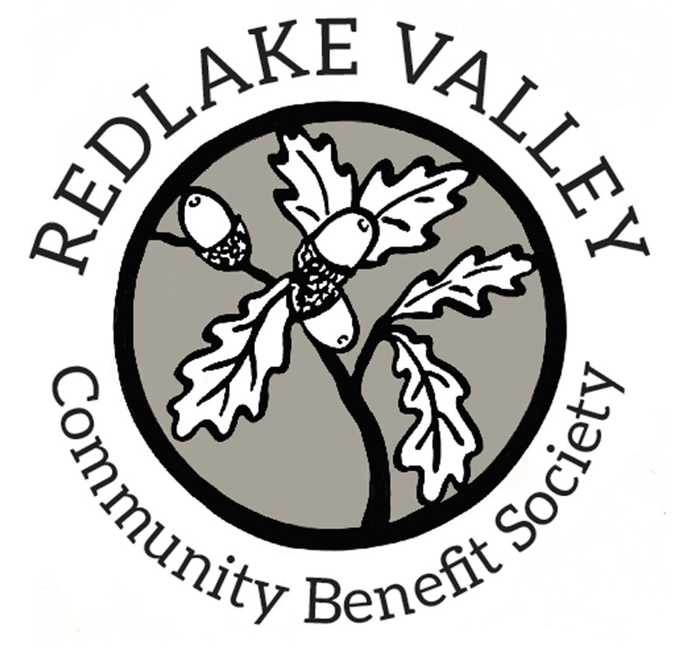
Minutes of Board Meeting
Held on line via Zoom
On Thursday 26th November 2020 at 7pm

Present: Patrick Cosgrove (PC) Bob James (BJ) Simon Jameson (SJ) Mark Limbrick (ML) Anthony Morgan (AM) Ros Patching (RP) Sara Randall (SR)

1. Welcome: ML welcomed members

2. Apologies: None

3. Declaration of interests: None

4. Minutes of last meeting (8th October 2020):
The Board agreed the minutes and ML signed them as a correct record. PC agreed to add them to the Society’s website.

5. Matters arising from the minutes:
ML was unable to confirm whether Karen Limbrick has contacted Patrick Faulkner. Action ML

6. Allot video:
The video was now viewable on the Society’s website.

7. Volunteering policy:
Revision of the draft policy had not been finished. ML promised to complete this task and circulate for comment. Action ML

8. New shareholders following website changes:
ML still intended to write to new shareholders and other supporters to let them know that they could register as “followers” and thus be notified of new additions as they were made. Action ML

9. Photo and memorabilia exhibition:
No draft specification was available but PC reminded members of the concept which was supported by all. After discussion it was agreed to plan for a date in early October 2021 which would allow time for the covid-19 pandemic restrictions to be out of the way. It would be good to involve the church and to share any profit. BJ agreed to establish and chair a steering group to take the initiative forward. He suggested that an article in the Redlake newsletter should be an early aim and that gathering ideas and volunteers will be needed. Action BJ

10. Hedge laying advertising:
An advertisement is now on the website and PC volunteered to place others on local notice boards. Action PC

11. Tesco community fund:
ML had suggested in August that the Tesco community fund might be a source of money to support the building of steps though possibly general woodland management might be more attractive. After discussion it was agreed that this fund should be thought of as one of several potential sources of money and included as such in overall fundraising plans.

12. Secretary’s role and responsibilities/documents:
PC had circulated a paper detailing a proposal for rationalizing and making more secure the Society’s records. A “cloud based” system accessible to all was not a practicable possibility. Instead, three directors would be responsible for primary data holding. All records would be held in digital format and each director would look after one area (for example finance) according to agreed principles such a password protection and local back-up. A fourth director would maintain a comprehensive independent back-up including all records from the other three. This proposal was endorsed and PC was asked to take things on to the next phase. Action PC

13. Website upgrade:
Thanks to PC the Society now has its own domain name (RedlakeValleyCBS.org) which links to the website on WordPress Personal which is free of advertisements.

14. First aid kit replacement:
ML was concerned that the Society was open to liability claims if anything went wrong whilst using an outdated first aid kit. It was agreed that a new one should be purchased. Action ML

15. Woodland management discussion paper:
AM had circulated a paper outlining the background to the Society’s ownership of woodland and the surveys and work which had been carried out. It now owns roughly a fifth of Brineddin Wood and has effective custodianship of much more so it is time to plan seriously for how the area should best be managed. The decline in biodiversity already recognized, particularly affecting ground flora, is the most serious concern – and a problem now recognized as important on a global scale. Three potential approaches were set out: wilding (let nature take its course), conservation (small scale input attempting to maintain the status quo at least) and re-introduction of coppicing (a more major change aiming to bring back the cyclical flourishing of biodiversity thought to have been associated with traditional management of the wood.)
PC made detailed comments and concluded that “do nothing” was not an option. Carrying on as now (conservation) was possible and non-contentious but was an acceptance that we are playing at management. Re-introduction of coppicing might stimulate opposition and would be resource-intensive. However it might capture people’s imagination and support because if was flavour of the moment in environmental terms.
Other members were generally supportive of taking the initiative to a next stage and AM was asked to consider getting further input from authoritative sources. Action AM

16. Revised fund-raising strategy:
RP’s paper on a way forward was well received. It set out the main reasons for fundraising, various ways of attracting money and some specific examples. It was agreed that the objective for the next year should be democratized fundraising with the objective of offsetting the Society’s loan. Shareholders form the group most likely to make efforts to raise money for this purpose and all sorts of small scale initiatives are possible. PC agreed to put a donation tab on the website. RP agreed to write to shareholders with some ideas and to formalize the objectives for 20/21. Action PC and RP

17. Chairman’s report:
ML reported that a shareholder had recently made a donation of £500. There had been no organized work parties because of the covid-19 lockdown but there had been independent work building steps on the quillets. More fencing rails for supports were required and it was agreed that they should be purchased. Action ML

18. Treasurer’s report:
The bank balance was £2813.10. The possibility of issuing invoices for hedge-laying work raises the question of the Society’s liability for corporation tax. HMRC currently regards RVCBS as dormant because it does not trade or provide services and so does not require it to make corporation tax returns. If RVCBS itself charges for work done this situation could change and liability to tax on any profit would arise. AM agreed to investigate what this would entail in administrative and cost terms. Action AM

19. Any other business:
PC proposed to register RVCBS with a list of community organizations maintained by the Midcounties Co-op. Action PC

19. Date of next meeting:
7 pm Thursday 21st January 2021
On-line video conference

Note: The meeting planned for 21st January took place on 25th February instead

*************

